**INTRODUCTION**

Bright Idea Consulting provides a wide range of services tailored to meet the unique needs of our clients. Our team of experienced consultants offers expertise in various areas, including:

1. **Business Strategy**: We help you develop and implement effective strategies to outperform the competition and achieve sustainable growth.
2. **Innovation and Creativity**: We foster innovation by nurturing creative thinking and helping you turn groundbreaking ideas into practical solutions.
3. **Management and Leadership**: Our leadership development programs and coaching services empower individuals and teams to lead with confidence and excellence.
4. **Market Research and Analysis**: We offer in-depth market insights to guide informed decisions and develop winning marketing strategies.
5. **Change Management**: Embrace change with confidence and adapt to new challenges by working with our change management experts.

**PURPOSE**

**Inspire Innovation:** We are committed to fostering a culture of innovation and creative thinking. Our purpose is to ignite the spark of imagination in our clients, helping them discover new and inventive ways to solve problems and seize opportunities.

**2. Drive Growth:** We strive to be the driving force behind the growth and expansion of the businesses and individuals we serve. Our purpose is to provide strategic insights, actionable plans, and unwavering support to propel our clients toward their goals.

**3. Empower Leadership:** Our purpose is to empower leaders to rise to their full potential. We guide individuals and teams to lead with confidence, vision, and effectiveness, creating a positive impact on their organizations and communities.

**4. Illuminate Possibilities:** We are dedicated to uncovering possibilities where others see roadblocks. Our purpose is to shine a light on new horizons, helping our clients navigate change, overcome challenges, and seize opportunities with clarity and purpose.

**5. Make a Meaningful Impact:** We measure our success by the meaningful impact we have on our clients' lives and businesses. Our purpose is to leave a lasting, positive imprint on the organizations and individuals we serve.

**6. Be a Trusted Partner:** Our purpose is to be a trusted and reliable partner on the journey to success. We are committed to building enduring relationships based on trust, integrity, and mutual respect.

**PROBLEM DEFINITION AND DESIGN THINKING**

EMPATHY MAP

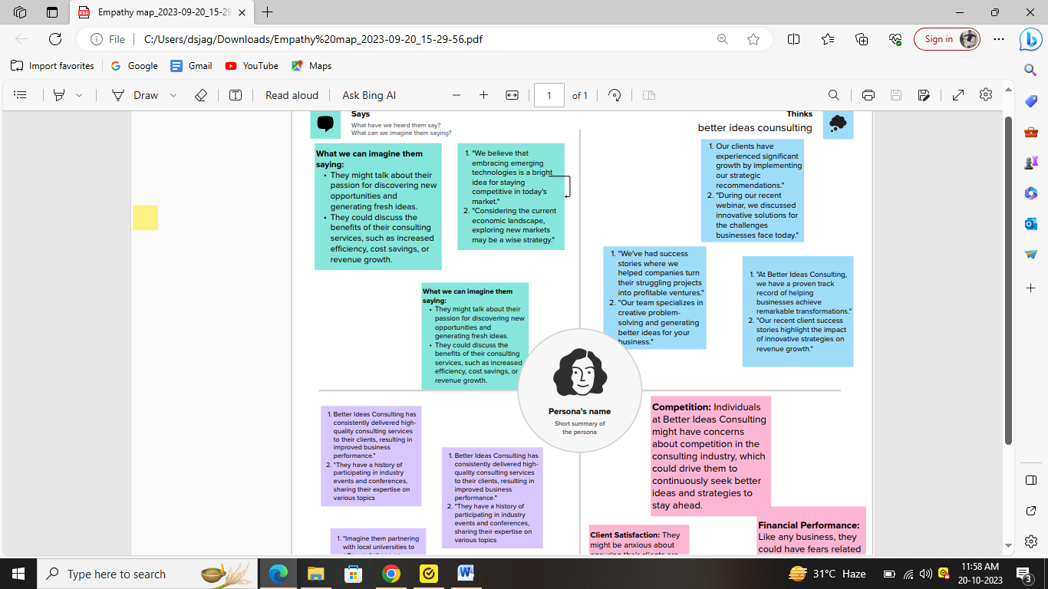**Empathy Map for Bright Idea Consulting Clients:**

**1. What Clients Say:**

* "We need to improve our market strategy."
* "Our team struggles with leadership and innovation."
* "We're facing significant organizational changes."
* "We have unique challenges specific to our industry."

**2. What Clients Think and Feel:**

* Clients may feel overwhelmed by their business challenges.
* They might be eager for fresh ideas and innovative solutions.
* Some clients could be uncertain about the future and seek clarity.

**3. What Clients See:**

* Clients see a competitive landscape where staying ahead is essential.
* They notice their teams' performance and the impact of their strategies.
* They may see their industry evolving and adapting to new trends.

**4. What Clients Hear:**

* Clients hear about the success stories of businesses in their industry.
* They listen to experts and consultants sharing insights and recommendations.
* They may receive feedback from their own teams regarding challenges and opportunities.

**5. Clients' Pains:**

* Clients might be experiencing frustration due to stagnant growth.
* They could be worried about a lack of innovation or the inability to adapt to change.
* They may find it challenging to align their teams with their strategic goals.

**6. Clients' Gains:**

* Clients hope to gain a competitive edge through improved strategies.
* They seek innovative ideas that can drive growth and market presence.
* They aim to develop effective leadership and management skills.

**7. Jobs to Be Done:**

* Clients are looking for expert consulting services to address their specific challenges.
* They need guidance in formulating and executing business strategies.
* They require support in fostering creativity and innovation within their organizations.

**IDEATION AND BRAINSROMING MAP**

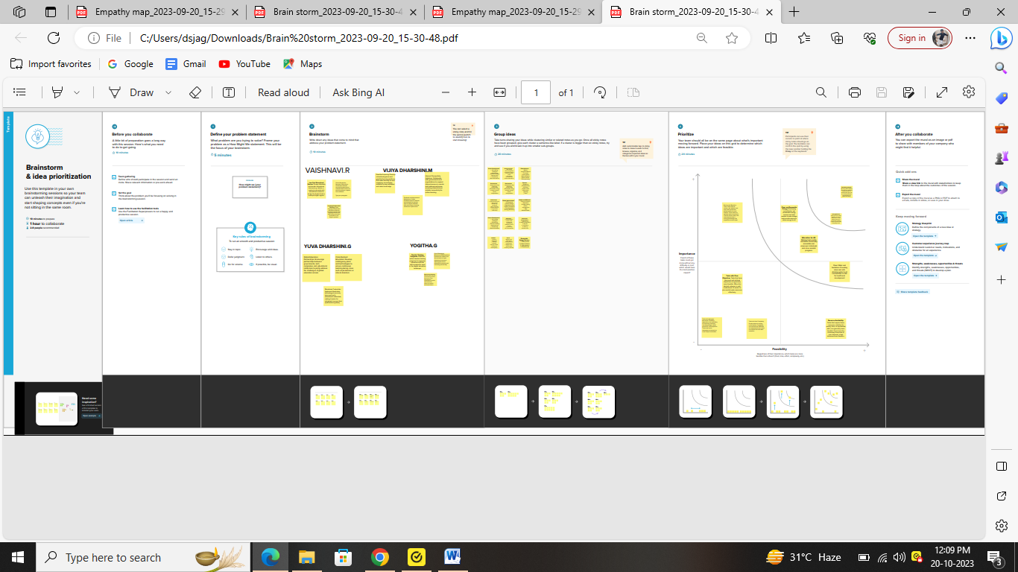**1. Objective:**

* Define the specific challenge or opportunity the client wants to address through ideation and brainstorming.

**2. Participants:**

* Identify key stakeholders and team members who will be involved in the brainstorming session.

**3. Setting:**

* Determine whether the session will be conducted in-person, virtually, or a hybrid model.
* Set the date, time, and duration for the brainstorming session.

**4. Ground Rules:**

* Establish guidelines for the session, including open-mindedness, respect for all ideas, and a focus on quantity over quality initially.

**5. Icebreaker:**

* Start the session with an icebreaker to foster creativity and build a positive atmosphere.

**6. Idea Generation:**

* This is the core of the session. Encourage participants to think freely and brainstorm ideas without judgment.
* Use techniques like mind mapping, analogies, role reversal, or brainstorming games.

**7. Idea Presentation:**

* Allow each participant to present their ideas to the group.
* Use visual aids, such as whiteboards, digital tools, or sticky notes, to display ideas.

**8. Group Evaluation:**

* Review and categorize ideas. Identify common themes, promising concepts, and unique suggestions.
* Discuss the feasibility and potential impact of each idea.

**9. Prioritization:**

* Vote or use a structured method to prioritize the most promising ideas.
* Focus on ideas that align with the client's objectives and resources.

**10. Action Plan:**

* Create an action plan to implement the selected ideas.
* Assign responsibilities and set deadlines for each step.

**11. Follow-up:**

* Schedule follow-up meetings to track progress, provide support, and make necessary adjustments.

**12. Documentation:**

* Keep detailed records of the ideation and brainstorming process, including all ideas generated and their status.

**13. Client Feedback:**

* Gather feedback from the client regarding the brainstorming session and the selected ideas.

**14. Implementation:**

* Support the client in implementing the chosen ideas and monitor their impact.

**RESULT**

**1. Introduction:**

* Briefly introduce the client, their specific challenge, and the purpose of the report.

**2. Empathy Map Findings:**

*What the Client Says:*

* Summarize the key statements made by the client regarding their challenge, goals, and expectations.

*What the Client Thinks and Feels:*

* Share insights into the client's thoughts and emotions related to the challenge, such as concerns, hopes, and aspirations.

*What the Client Sees:*

* Describe the client's observations of their industry, market, and competitors that may impact their situation.

*What the Client Hears:*

* Highlight the sources of information and opinions that influence the client's decision-making.

*Client's Pains:*

* Identify the client's pain points, frustrations, and obstacles related to the challenge.

*Client's Gains:*

* Enumerate the client's desired outcomes and what they aim to achieve through consultation.

*Jobs to Be Done:*

* Define the tasks the client expects Bright Idea Consulting to help them with.

**3. Brainstorming Session:**

*Objective:*

* State the purpose of the brainstorming session, such as generating innovative solutions to address the client's challenge.

*Participants:*

* List the team members and stakeholders involved in the brainstorming session.

*Setting:*

* Specify the location and format (in-person or virtual) of the brainstorming session.

*Ground Rules:*

* Mention any guidelines or rules set for the brainstorming session to ensure a productive and creative environment.

*Ideation Techniques:*

* Briefly describe the techniques used during the brainstorming session, such as mind mapping, analogies, or role reversal.

*Ideas Generated:*

* Summarize the ideas generated during the session, providing a broad overview of the concepts explored.

*Selected Ideas:*

* Highlight the most promising and relevant ideas that emerged from the brainstorming session.

**4. Recommendations:**

* Suggest recommendations based on the selected ideas to address the client's challenge effectively.

**5. Action Plan:**

* Outline a step-by-step action plan for implementing the recommended ideas. Specify responsibilities, timelines, and resources required.

**6. Conclusion:**

* Summarize the key takeaways from the combined empathy map and brainstorming session, emphasizing the client's needs, the creative solutions, and the proposed action plan.

**7. Next Steps:**

* Provide information on the follow-up steps, including future consultations and the monitoring of progress.

**8. Client Feedback:**

* Mention any feedback received from the client regarding the empathy map and brainstorming session.

**9. Appendices:**

* Include any supplementary materials, detailed brainstorming notes, or additional information relevant to the report.

**VIJAYA AGENCIES**

Profit and loss

Basis accrual

From 01/04/2023to31/03/2024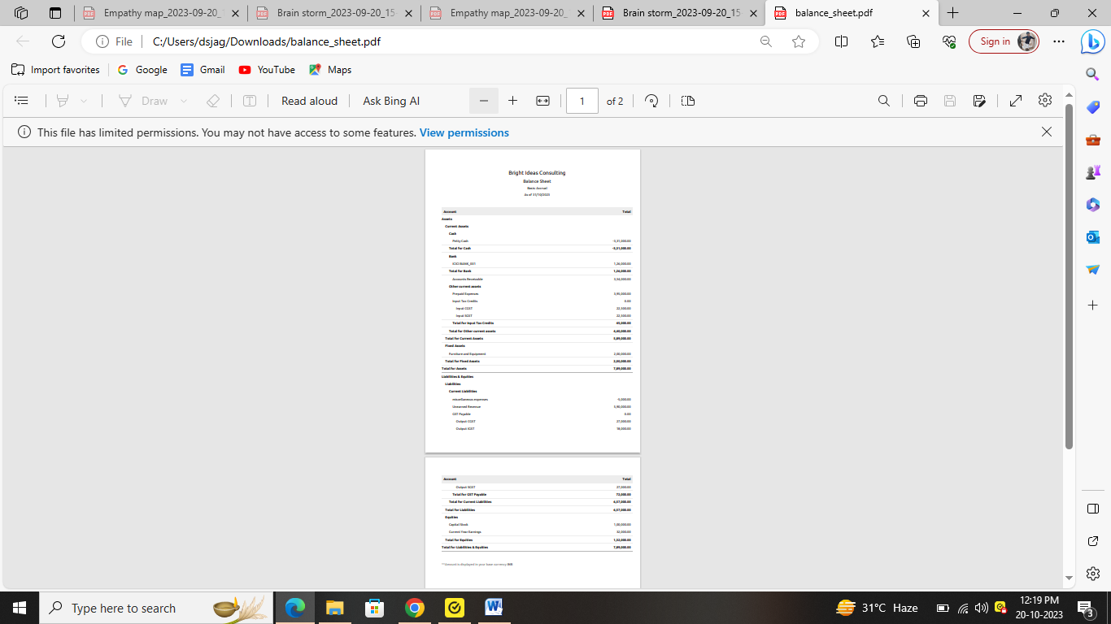

Top of Form

Top of Form

VIJAYA AGENCIES

Balance sheet

Basis accrual

As of 31/03/2024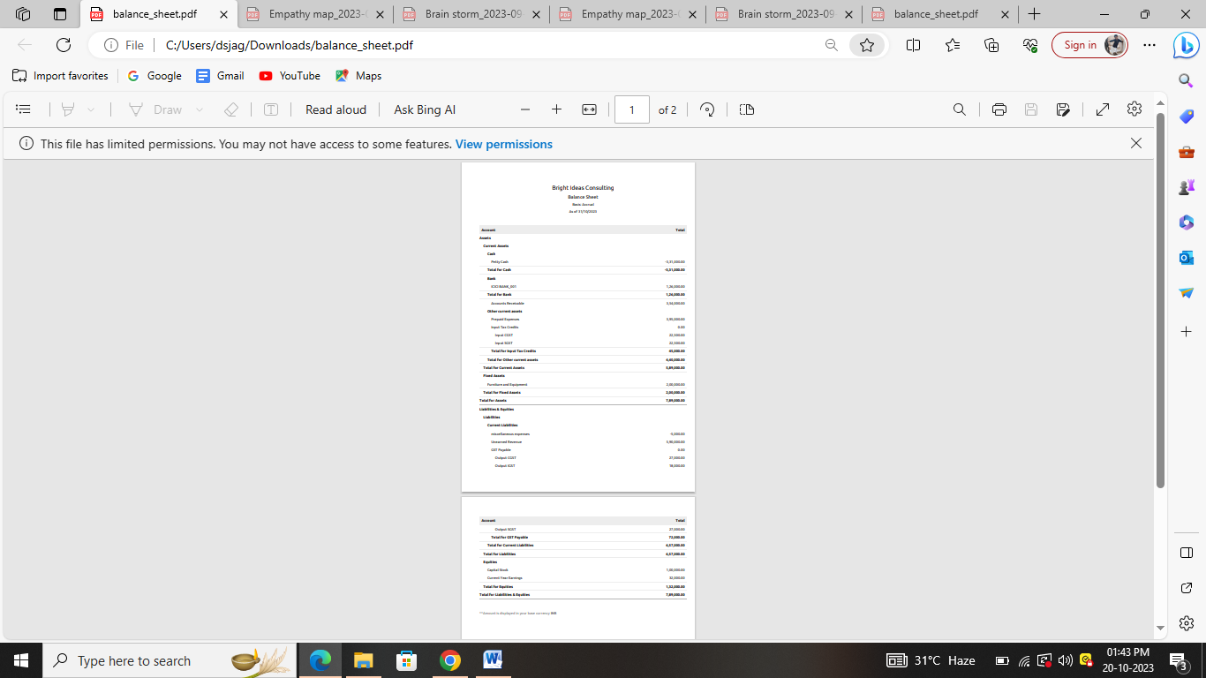Top of Form

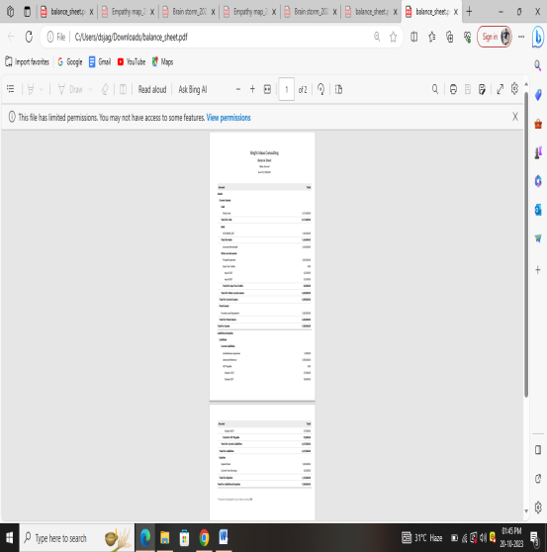

**ADVANTAGES &DISADVANTAGES**

**ADVANTAGES**

1. **Expertise and Knowledge**: Consulting firms typically have a team of experts with specialized knowledge in various fields, industries, or disciplines. They can provide valuable insights and recommendations based on their extensive experience and expertise.
2. **Fresh Perspective**: Consultants bring an outside perspective, which can help identify opportunities and solutions that may not be apparent to the client. They can offer a fresh and objective viewpoint on challenges and strategies.
3. **Customized Solutions**: Consulting firms tailor their services to meet the specific needs and goals of each client. This ensures that the solutions provided are relevant and effective for the client's unique situation.
4. **Efficiency and Focus**: Consultants can expedite the decision-making process and implementation of strategies. They allow clients to focus on their core business activities while the consulting firm handles the specialized tasks.
5. **Problem-Solving**: Consulting firms are skilled in problem-solving. They can help clients analyze complex issues, identify root causes, and develop practical solutions to overcome challenges.
6. **Cost-Effective**: Hiring a consulting firm can often be more cost-effective than hiring full-time, in-house experts. It allows clients to access specialized knowledge and skills without the long-term commitment and expenses associated with hiring employees.
7. **Objective Advice**: Consultants provide unbiased advice and recommendations. They don't have the same emotional attachments or biases that internal employees might have, leading to more objective decision-making.
8. **Access to Resources**: Consulting firms typically have access to a wide range of resources, tools, and networks that can benefit their clients. This access can include market research, industry data, and best practices.
9. **Innovation and Creativity**: Consulting firms often bring innovative and creative thinking to the table. They can help clients think outside the box and develop cutting-edge solutions.
10. **Project Management**: Consultants are skilled in project management and can help clients plan and execute complex projects efficiently and effectively.
11. **Risk Mitigation**: Consulting firms can help clients identify and mitigate dsecure and successful outcome.
12. **Scalability**: Consulting firms can scale their services to meet the changing needs of a client. Whether it's a small project or a comprehensive transformation, they can adapt their services accordingly.
13. **Measurable Results**: Consultants often focus on delivering measurable results. They set clear objectives and key performance indicators (KPIs) to track progress and ensure that their services are effective.
14. **Time-Saving**: By leveraging the expertise of a consulting firm, clients can save time and effort in problem-solving, planning, and implementation.
15. **Confidentiality**: Consulting firms typically uphold strict confidentiality standards, ensuring that sensitive business information remains protected.
16. **Staying Competitive**: In a fast-paced business environment, consulting firms help clients stay competitive by keeping them informed about industry trends and best practices.

**DISADVANTAGES**

1. **Cost**: Hiring a consulting firm can be expensive. The fees charged by consultants can be a significant cost, especially for small businesses and individuals with limited budgets.
2. **Dependence on External Experts**: Relying on external consultants can lead to a dependency on their expertise. This may prevent clients from developing their in-house capabilities over time.
3. **Limited Understanding**: Consultants may not fully understand the internal dynamics, culture, and nuances of the client's organization. This can hinder their ability to provide context-specific recommendations.
4. **Confidentiality Concerns**: Sharing sensitive information with external consultants can raise confidentiality concerns. Ensuring data security and protection may be more challenging when working with outside experts.
5. **Potential for Misalignment**: If there's a misalignment between the client's goals and the consultant's recommendations, it can lead to dissatisfaction and unproductive results.
6. **Resistance to Change**: Employees within the client organization may resist changes recommended by consultants, leading to implementation challenges.
7. **Lack of Ownership**: Clients may not take ownership of the solutions proposed by consultants, which can result in a lack of commitment to implementation.
8. **One-Size-Fits-All Solutions**: Some consulting firms may rely on standard solutions or frameworks that may not fully address the unique needs and challenges of the client.
9. **Time-Consuming Process**: Engaging with consultants can be time-consuming, as it often involves meetings, data gathering, and reporting, diverting resources away from day-to-day operations.
10. **Scope Creep**: The scope of consulting projects can sometimes expand beyond the initially agreed-upon parameters, leading to increased costs and timelines.
11. **Incompatibility with Organizational Culture**: Consultants and their methods may not align with the client's organizational culture, which can create friction and resistance.
12. **Limited Transfer of Knowledge**: Some consulting firms may not focus on knowledge transfer. As a result, clients may not learn how to solve similar issues in the future without further external assistance.
13. **Ineffective or Unqualified Consultants**: Not all consulting firms are equally skilled or reputable. Clients must carefully select a consulting partner to avoid working with inexperienced or unqualified consultants.
14. **Conflict of Interest**: Clients should be cautious about potential conflicts of interest, particularly when consulting firms have relationships with other organizations or vendors.
15. **Overemphasis on Deliverables**: Some consulting engagements may prioritize deliverables over tangible results, resulting in a focus on paperwork rather than actual impact..

**CONCLUSION**

At Bright Idea Consulting, our commitment to empowering businesses and individuals to reach their full potential shines through in everything we do. We're more than just a consulting firm; we're your partner in innovation, strategy, and success. With a dedicated team of experts, a client-centric approach, and a passion for creative problem-solving, we're here to illuminate the path to your brightest ideas.

As we navigate the ever-evolving landscapes of business and leadership, our mission remains steadfast. We're here to provide you with the expertise, insights, and support needed to drive growth, foster innovation, and overcome challenges. We believe in the power of fresh ideas, strategic thinking, and empathetic guidance.

**FUTURE SCOPE**

1. **Digital Transformation and Technology Consulting**: As technology continues to reshape industries, there will be a growing demand for consulting services related to digital transformation, cybersecurity, artificial intelligence, and data analytics.
2. **Sustainability and Environmental Consulting**: With a focus on sustainability and environmental responsibility, there will be increased demand for consulting services to help organizations reduce their environmental footprint and adhere to green standards and regulations.
3. **Change Management and Resilience Consulting**: In an era of constant change and disruption, consulting firms will play a crucial role in helping organizations adapt to change, build resilience, and effectively manage transitions.
4. **Innovation and Creativity Consulting**: As innovation becomes a key driver of success, consulting firms will help businesses foster creative thinking, develop new products and services, and stay ahead of the competition.
5. **Health and Wellness Consulting**: The importance of employee well-being and health will continue to rise. Consulting services that focus on promoting mental health, work-life balance, and wellness programs within organizations will be in demand.
6. **Global Expansion and Market Entry Consulting**: As companies look to expand into new markets, consulting firms will assist with market entry strategies, international business regulations, and cultural adaptation.
7. **AI and Automation Consulting**: With the growing use of artificial intelligence and automation, consulting firms will guide organizations in implementing and optimizing these technologies to enhance efficiency and productivity.
8. **Diversity and Inclusion Consulting**: There will be a growing need for consulting services that help organizations foster diverse and inclusive workplaces, address biases, and promote equality.
9. **Remote Work and Hybrid Workforce Consulting**: The shift toward remote and hybrid work models will create demand for consulting services that assist organizations in adapting to these new work arrangements, maintaining productivity, and ensuring employee engagement.
10. **Healthcare and Telemedicine Consulting**: The healthcare sector, including telemedicine and digital health solutions, will continue to evolve. Consulting firms with expertise in healthcare can assist providers and organizations in navigating this dynamic industry.
11. **Supply Chain Resilience Consulting**: Recent disruptions have highlighted the importance of resilient supply chains. Consulting firms can offer strategies to enhance supply chain stability and risk management.
12. **Legal and Regulatory Compliance Consulting**: As regulations evolve, businesses will require consulting services to navigate complex legal and compliance requirements, especially in highly regulated industries.
13. **Ethics and CSR Consulting**: There's a growing emphasis on corporate social responsibility (CSR) and ethical business practices. Consulting firms can guide organizations in developing and maintaining responsible business strategies.
14. **Customer Experience Consulting**: In an era of customer-centricity, consulting firms can help businesses optimize customer experiences, improve customer satisfaction, and drive loyalty.
15. **Education and Training Consulting**: With lifelong learning becoming essential, consulting firms may expand into education and training services, helping individuals and organizations acquire new skills and knowledge.

Top of Form

Top of Form

Top of Form

Top of Form

Top of Form